Pathogenicity of different entomopathogens on white grubs of Lepidiota mansueta (Burmeister) (Coleoptera: Scarabaeidae) under laboratory conditions
Authors
Sravani Dumala*^{1,2}, Badal Bhattacharyya³, Purnima Das⁴, Binita Borah⁵ and Balaga Mohan Ganesh⁶

^{1,3,4,5,6}Department of Entomology, College of Agriculture, Assam Agricultural University, Jorhat, 785013, Assam, India
²Department of Agriculture, Koneru Lakshmaiah Education Foundation, Green Fields, Vaddeswaram, Guntur, 522302, Andhra Pradesh, India

¹*Correspondence author: e-mail- sravanidumala@gmail.com, 7981801908.
² badalassam@gmail.com
³ purnima.das@aau.ac.in
⁴ borahbinita22@gmail.com
⁵ balagaganesh1995@gmail.com
Abstract
The present research study was conducted to evaluate the efficacy of six different entomopathogenic fungi and bacterial formulation against the third-instar grubs of a subterranean biennial white grub species, Lepidiota mansueta. All treatments proved effective, recording over 55 percent mortality of white grubs compared to the untreated control at 30 days after treatment (DAT). However, the highest cumulative mortality (76%) was observed in Beauveria bassiana (KR855715), followed by 72 percent in Beauveria brongniartii (BbUASB₁₆) and 70.67 percent in Bio-Bt (Bacillus thuringiensis) treated grubs. Metarhizium anisopliae-based formulation (Bio-Meta) exhibited the lowest mortality rate (58.67%). Overall, B. bassiana (KR855715) and B. brongniartii (BbUASB₁₆) demonstrated higher virulence towards L. mansueta grubs, indicating their potential as biological control agents against these pests. The LT₅₀ values varied from 12.15 to 23.05 days when L. mansueta grubs were treated with different entomopathogenic treatments. In case of KR855715 strain, the LT₅₀ value recorded was 12.15 days (FL 11.15-13.11) which was the lowest and in Bio-Meta, the LT₅₀ recorded was 23.05 days (FL 19.24-30.33) which was the highest. In conclusion, as chemical pesticides are not always the best option for controlling scarabs, entomopathogenic fungus can be incorporated into integrated pest management (IPM) strategies as biological control agents. This is especially useful for managing populations of early-season white grubs. Therefore, to keep the pest population in an environmentally balanced level and to provide long-term control for the grubs, these tested entomopathogens may serve as possible biocontrol agents against L. mansueta grubs.
Keywords: pathogenicity, entomopathogenic fungi, white grub, Lepidiota mansueta
Introduction
Scarab beetles (Coleoptera: Scarabaeidae) are cosmopolitan insects and are found on all continents except Antarctica. They are one of the most recognizable and studied taxons of beetles due to their size, vibrant colors, and most importantly their role in the ecosystem. Scarabaeidae (Coleoptera) comprises over 30,000 beetle species worldwide. Over a thousand species of white grubs have been identified in the Indian subcontinent (Veeresh et al., 1991). These pests, considered a national menace, have been extensively studied, with nearly 300 species recorded in India alone (Shivayogeshwara and Veeresh, 1983; Bhawane et al., 2011). Due to their polyphagous nature, white grubs cause significant damage, leading to losses of up to 70% in crops such as sugarcane, groundnut, potato, maize, and upland rice. Despite efforts, no single management method has provided a lasting solution against these pests (Yadava and Sharma, 1995).
Lepidiota mansueta (Burmeister) (Coleoptera: Scarabaeidae), an endemic biennial white grub species, has become a significant pest in the Majuli River island of Assam. It has recently been observed to significantly damage many crops in Majuli, Assam, North East India, with the extent of damage varying from 42-48% in potato, 35-40% in Colocasia, 30-35% in green gram, and 15-20% in sugarcane crop (Bhattacharyya et al., 2015; Bhattacharyya et al., 2017). According to reports, the sugarcane crop in Queensland and New South Wales, Australia, was severely damaged by 13 species of white grubs from the genus Lepidiota (Allsopp, 2010). The most devastating stages, second and third instar grubs feed on the fibrous roots of young plants and tubers and create shallow, circular cavities. It is extremely difficult to foresee the spotty and localized damage caused by the white grub because its infestation varies from year to year and from place to place. The damage is only evident when the plant dries up (Chandel et al., 2003; Bhattacharyya et al., 2015).
While pesticides have undoubtedly contributed to enhancing agricultural production by mitigating pest damage, the ecological repercussions of synthetic pesticides cannot be ignored. They have led to unprecedented environmental damage, the development of resistance in insects, and serious health risks for workers involved in their manufacture, formulation, and application in the field. To address these issues, the use of biocontrol agents has emerged as one of the most promising alternatives to chemical control methods. The potential of biocontrol agents in combating various insect pests has garnered global attention in recent decades. Among the effective biopesticides, certain bacteria species like Bacillus (Kati et al., 2007; Sezen et al., 2007) and fungi species such as Beauveria and Metarhizium (Tinline and Zacharuk, 1960; Sevim et al., 2010) have demonstrated relatively higher efficacy. The potential use of fungi against insects as disease causing agents was studied for over a century, and there are about 1000 Entomopathogenic Fungi (EPF) that can kill insects (Shang et al., 2015). The EPF had shown their efficacy against many insect pests causing the infection by contact of fungal propagules to the host cuticle followed by penetration, vegetative growth on the host, using either enzymes or toxins, and eventually leads to death of their host (Ortiz-Urquiza and Keyhani, 2013). The advantage of EPF over other entomopathogens (bacteria and viruses) is that they can infect their host not only through diet but also directly from the spiracles and insect cuticle. The EPF represents the inherent group of biocontrol agents in the integrated management of seasonal scarabaeid pests worldwide. The EPF exhibit effectiveness by efficiently inducing host mortality for long-term, fostering increased genetic variability, ensuring environmental and vertebrate safety, and preventing the development of resistance in insects. Nevertheless, the stability, sensitivity, persistence, and success of EPF against hosts depend on various biotic and abiotic factors such as sunlight, temperature, humidity, substrate, chemical pesticides, interactions among the fungus, its target host as well as with antagonistic organisms (Lingg and Donaldson, 1981), time of exposure and developmental stage of the insects coupled with soil temperature, moisture (Studdert et al., 1990) and soil type (Storey et al., 1989). More than 100 pathogenic bacterial species are widely utilized for managing insect pest populations, with Bacillus thuringiensis, an entomopathogenic bacterium, being the most prevalent. While various control methods, like biological agents, can complement these bacteria, their optimal efficacy occurs when applied during the early stages of immature larvae, particularly the first and second instars. The main aim of the present experiment was to evaluate the pathogenicity of some EPF and bacterial formulations against L. mansueta grubs under laboratory conditions.
Materials and methods
Collection of L. mansueta grubs
In laboratory studies, third instar grubs of L. mansueta were utilized as test insects, requiring a considerable number of grubs to conduct the experiments. These grubs were sourced from highly endemic areas of Majuli river island between August and October 2020, using 1 m³ pits for excavation. After collection, the grubs were placed into plastic disposable cups (200 ml in size) containing moist soil and cut potato tuber pieces as food, and then transported to the Soil Arthropod Pests Laboratory, Department of Entomology, Assam Agricultural University (AAU), located in Jorhat, Assam. The investigations were conducted in Jorhat (longitude: 94°22´E, latitude: 26°75´N, altitude: 91.0 m above mean sea level) and Majuli district (longitude: 93°39 E to 94°35 E, latitude: 26°45 N to 27°12 N, altitude: 84.50 m above mean sea level) of Assam. These areas are situated in the upper reaches of the Brahmaputra, approximately 630 km upstream of the Indo-Bangladesh border.
Maintenance of insect cultures for laboratory research
Soil collected from Majuli island underwent sieving, sterilization, and was stored sealed at room temperature until one day prior to use. Individual grubs were then placed in plastic disposable cups (200 ml) containing moistened soil collected from the field (substrate) and cut potato tubers (food source). The cups were covered with a piece of muslin cloth and secured with a rubber band to ensure adequate aeration. The grubs were kept in rearing cages at ambient room temperature (25±5°C) and humidity (75±5% RH) for one week to acclimate to laboratory conditions. Throughout this acclimatization period, grubs displaying symptoms of disease were identified and removed, with regular replacement of substrate and food every six days. Only uniform-sized and uninfected grubs were selected for the experiments. Specifically, last instar grubs, characterized by a high feeding rate, weight gain, and increased haemolymph content, were utilized for testing the pathogenicity of various entomopathogens in the experiments, following the methodology outlined by Manachini et al. (2011).
Pathogenicity tests
The bioassay was conducted using 6 entomopathogenic products/strains along with one untreated control (only water suspension was used) against L. mansueta grubs at room temperature, with five replications and 15 insects per replication in each treatment. The entomopathogens utilized in the current study are detailed in Table 1. They include Bacillus thuringiensis (Bio-Bt), Beauveria brongniartii (BbUASB₁₆), Metarhizium anisopliae (Bio-Meta) and Beauveria bassiana formulations, specifically IMI335352 (WP formulation) (Rice Hispa isolate), Bio-Sona, and KR855715 (WP formulation) (Tea mosquito bug isolate).

Table 1. Specifications of the entomopathogenic products/strains used for the study.
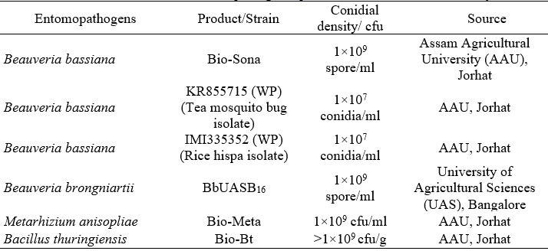
This investigation followed a completely randomized design. Sterile soil-filled disposable cups (8 × 7 cm) served as experimental units, each containing 50 g of soil, a piece of cut potato (as the grub's food source), and a single third instar grub of L. mansueta. Entomopathogenic fungi formulations were prepared in the required amounts. For each treatment, 75 grubs were individually dipped into the entomopathogenic formulation for five seconds, using forceps to hold them loosely by the leg (Goettel and Inglis, 1997). The bacterial formulation (Bt) was applied topically to the cut potato tubers and fed to L. mansueta grubs. Grubs in the control group were treated with distilled water mixed with Tween-80 (0.023%). After excess liquid was allowed to drip off, the grubs were individually placed into the disposable plastic cups containing sterile soil and a cut potato piece.
Mortality data were recorded from seven to thirty days post-inoculation. Dead grubs were placed on moistened filter paper inside petri dishes (10 cm) and then incubated at 26±1°C for 5-7 days to facilitate fungal outgrowth from the cadavers. Subsequently, they were observed under a Phase contrast microscope. Petri dishes were thoroughly washed with clean water, dried at room temperature, wrapped in brown paper to prevent contamination, and oven dried for further use. Sterilization of the petri dishes was conducted in a hot air oven at 160°C for 2 hours.
Statistical analysis
The mortality data for the number of deceased grubs in each treatment at various time intervals were recorded, and percentage mortality data were transformed prior to conducting Analysis of Variance (ANOVA) with a Completely Randomized Design (CRD) as described by Puzari et al. (1994). The comparisons of means were performed using Duncan’s Multiple Range Test (DMRT) at the 0.05% significance level. Additionally, the mortality data for grubs at different time intervals were subjected to probit analysis, following the method outlined by Finney (1964), using SPSS software to calculate the Median Lethal Time (LT₅₀) for all tested entomopathogens.
The percentage of mortality was calculated using the following formula.
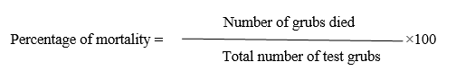
Results
Pathogenicity of entomopathogens against third instar L. mansueta grubs
The findings of this study illustrate the pathogenicity and virulence of entomopathogens against L. mansueta grubs under controlled laboratory conditions. At seven days after treatment (DAT), the mortality of third instar L. mansueta grubs ranged from 26.67 percent to 37.33 percent. Results indicated a gradual increase in mortality rates with prolonged exposure to different entomopathogenic treatments. All treatments demonstrated effectiveness, resulting in over 55 percent mortality of grubs compared to the untreated control after 30 DAT. Among the treatments, KR855715 exhibited the highest cumulative mortality at 76 percent, followed by BbUASB₁₆ at 72 percent, Bio-Bt at 70.67 percent, Bio-Sona at 69.33 percent, and IMI335352 at 66.67 percent. Conversely, the lowest mortality rate (58.67%) was recorded in the case of Bio-Meta (a formulation based on M. anisopliae). Notably, no mortality was observed in the control group.
Cadavers were placed on moistened filter paper in petri dishes and incubated at a temperature of 26±1°C. Following incubation for 5-7 days, fluffy fungal growth was observed on the surface of the treated deceased grubs (Fig. 1).
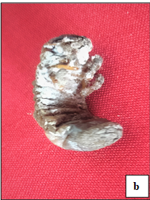
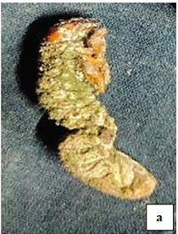
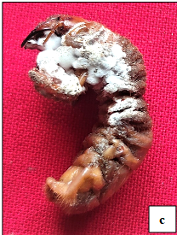
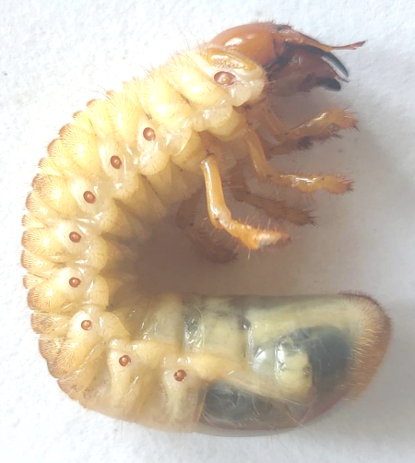
d
c
a
Fig. 1. L. mansueta grub cadavers infected with: (a-b) Beauveria; (c) Metarhizium anisopliae; d) untreated control.
Table 2. Effect of entomopathogenic products/strains on mortality of third instar grubs of Lepidiota mansueta.
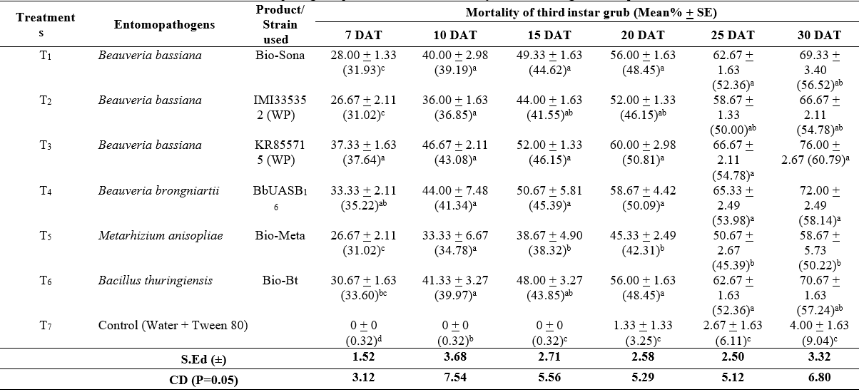
* Sample size: 75 insects (15 insects/replication)
* The data provided represent the means derived from 5 replications.
* Means followed by the same letter are not significantly different [DMRT, (P<0.05)]
* Values enclosed within parentheses represent angular-transformed data.
* DAT=Days After Treatment.
Median Lethal Time (LT₅₀) evaluation of entomopathogenic products/strains on L. mansueta grubs
The potential efficacy of various entomopathogens against grubs of L. mansueta was assessed by calculating LT₅₀ values under controlled laboratory conditions. The recorded LT₅₀ values are summarized in Table 3 and graphically depicted in Fig. 2. The LT₅₀ values ranged from 12.15 to 23.05 days when L. mansueta grubs were subjected to various entomopathogenic treatments. The highest LT₅₀ value was observed in Bio-Meta at 23.05 days (FL 19.24-30.33), while the lowest LT₅₀ value was recorded for KR855715 at 12.15 days (FL 11.15-13.11). Specifically, LT₅₀ values were 15.36 days (FL 14.37-16.40) for Bio-Sona, 17.60 days (FL 16.47-18.88) for IMI335352, 13.51 days (FL 11.40-15.58) for BbUASB₁₆, and 14.93 days (FL 13.91-15.98) for Bio-Bt. In descending order, the LT₅₀ values of the tested entomopathogens were: 23.05 days (Bio-Meta) > 17.60 days (IMI335352) > 15.36 days (Bio-Sona) > 14.93 days (Bio-Bt) > 13.51 days (BbUASB₁₆) > 12.15 days (KR855715).
Table 3. Mortality time response of L. mansueta grubs due to entomopathogenic products/strains.
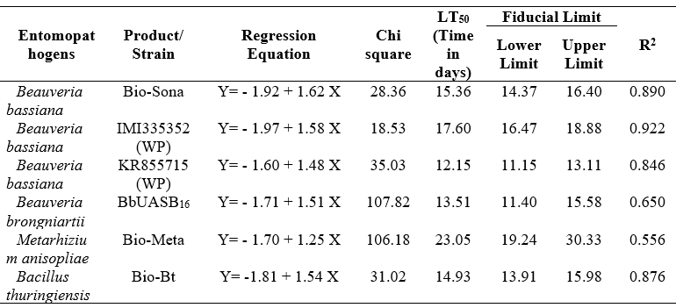

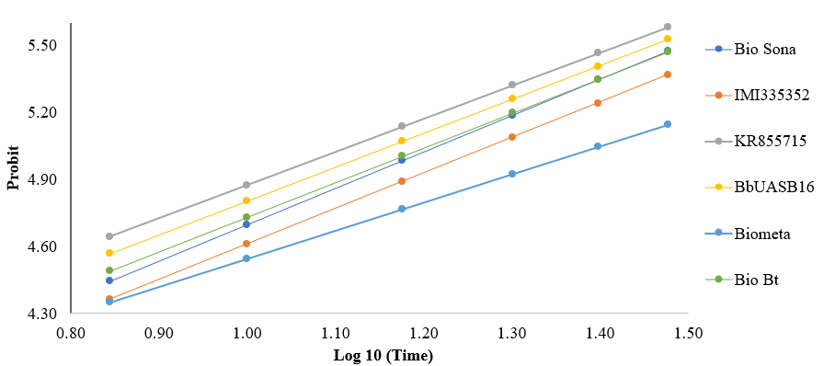
Fig. 2. Time response curve of L. mansueta grubs exposed to entomopathogenic products/strains at
different time intervals.

Discussion
Repeated and injudicious use of insecticides has resulted in development of insecticidal resistance in pest populations and high chemical residues in soil, which are hazardous to non-target organisms as well as the environment. In addition to the above, the withdrawal of many registered chemicals from the market has made the management of white grubs a monumental challenge. Considering the facts, the present study has been carried out to evaluate various entomopathogens against grubs of L. mansueta under laboratory conditions. Our observations have led us to conclude that EPF could be a promising biocontrol method of pest management as opposed to alternative control methods due to their ability to be self-replicative, ecologically friendly and target specific.
Although the efficacy of different EPF and bacteria against economically important species of white grubs have been previously detailed by many researchers, laboratory trials against L. mansueta grubs are yet to be undertaken. Laboratory bioassays are essential to determine the effectiveness of EPF against insect pests before field application (Cherry et al., 2005). Concurrent to the findings of the present study, isolates of B. bassiana were considerably more virulent to most soil-dwelling insect pests than M. anisopliae, according to Beron and Diaz (2005).
Dumala et al. (2023) reported that pre sowing treatment of mustard oil cake @ 150 kg/ha + wood ash @ 150 kg/ha + Panchagavya @ 3% plus application of M. anisopliae @ 10 g/m² after 1st & 2nd earthing up (25 & 60 DAS)] recorded the lowest tuber damage caused by L. mansueta grubs on weight (11.32%) and number (14.07%) basis, highest tuber yield (122.71 q/ha) and maximum benefit cost ratio (2.86) in potato. The presence of ample moisture in the soil during the rainy season facilitates the natural proliferation of fungi under field conditions. Field spraying with M. anisopliae (1x10⁸ spores/ml @5ml/l) outperformed B. bassiana (1x10⁸ spores/ml @5ml/l) contributing to crafting an environmentally sustainable integrated pest approach for combating Leucopholis coneophora Burmeister in the climate-resilient areas of India (Seram et al., 2023).
Patel et al. (2022) concluded that plots treated with soil application of vermicompost @ 1 ton/ha + M. anisopliae 1.15 WP @ 2 kg/ha recorded less (0.19) number of white grubs per one meter row length and the least amount of plant mortality was observed due to groundnut white grub, Holotrichia consanguinea that showed statistical parity with plots treated with castor cake (@ 1 ton/ha) + M. anisopliae 1.15 WP (@ 2 kg/ha) and neem cake (@ 1 ton/ha) + M. anisopliae 1.15 WP (@ 2 kg/ha) with only 1.74, 2.00 and 2.24% plant damage, respectively. The efficacy of the bio-formulations, comprising entomopathogenic fungi, can be augmented by enriching them with diverse organic supplements, including vermicompost, castor cake, and neem cake.
M. anisopliae caused 70 percent mortality of cassava white grubs (Lepidiota stigma; Coleoptera; Scarabaeidae) at a concentration of 10⁷ spores/L after 72 hours of inoculation due to the epizootic conditions emerging in the population after inoculation for more than 7 days. The enhanced efficacy of M. anisopliae fungus during rainy seasons could be due to the conducive wet and humid conditions that promote its proliferation (Wagiyana et al., 2021). Rahman et al. (2021) observed that the bio pesticides, M. anisopliae and B. bassiana @ 5.0 kg ha⁻¹ could serve as environment friendly alternatives to chemical control methods, potentially reducing the reliance on chemical insecticides for managing sugarcane white grubs, Holotrichia seticollis. This approach not only has the potential to lower management costs but also ensures environmental safety.
A previous study by Laznik and Trdan (2015) has determined that in an organically managed meadow with dry forage preservation, white grub management was achieved using B. thuringiensis var. tenebrionis and entomopathogenic fungi, alone or in conjunction with EPNs. They noted a synergistic effect between B. bassiana and Heterorhabditis bacteriophora, targeting first grubs. Similiarly, the findings of Laznik et al. (2012) report that B. thuringiensis var. kurstaki had the most significant effect on the average count of white grubs of June beetles, margined vine chafers, and garden chafers, in a permanent cut grassland. Their study revealed that applying this treatment in April reduced the population of overwintered grubs and resulted in an 8% increase in dry matter yield during the first cut. Entomopathogens serve as a viable alternative to chemical control, as chemical application on lawns is restricted in most parts of the world.
In a study conducted by Prabhu et al. (2011), the efficacy of bioagents and plant products was assessed in the field against the arecanut root grub, Leucopholis lepidophora. The bioagent M. anisopliae, applied at a rate of 2×10⁸ conidia/g at 20 g per palm, resulted in a mortality rate of 31.38 percent among third instar grubs. The researchers recommended incorporating the fungus culture during the onset of the monsoon season, coinciding with the emergence of beetles in large numbers and their egg-laying phase. This timing was chosen due to the presence of overlapping generations in the field. They noted that early instar grubs, which primarily feed on decaying matter, were more susceptible to infection by the pathogen. Furthermore, the pathogen's multiplication in the soil following early infection contributed to the buildup of soil inoculum, which subsequently targeted older grubs that required higher inoculum levels.
White grubs are amongst the toughest soil insect pests to manage because of their strong pesticide resistance (Buss, 2006). More critically, it is challenging to apply enough pesticide to the root zone since grubs feed and spend most of their lifespan inside the soil. According to Tunaz and Stanley (2009), soil-dwelling insects like white grubs may be more exposed to pathogens. When congenial environmental conditions prevail, spores of EPF can encounter the insect cuticle, germinate and grow directly and proliferate on an insect's living body and penetrate by enzymatic degradation and eventually kill the host by mechanical organ blockage and by producing toxins. The host's developmental stage has a significant impact on the results of bioassays and how susceptible they are to entomopathogenic fungi (Dimbi et al., 2003). The interrelationship between the susceptibility of white grub and the pathogenicity of entomogenous fungi is highly complex and the primary defense against entomopathogenic infection in insects is the cuticle. With advancing physiological age, the structural elements of the white grub cuticle probably change, altering their susceptibility to infection (Nong et al., 2011). Nelson et al. (1996) reported that the high potential of B. bassiana might be due to the ease with which it may be cultured on media with subsequent production of large number of conidia. Dhoj et al. (2008) reasoned that the higher susceptibility of Phyllognathus dionysius against M. anisopliae isolates, M1 might be due to their bigger and firmer body size that provides more space to pick up conidia compared to the other two white grub species viz., Anomala dimidiata and Adoretus lasiopygus with a smaller body size. Additionally, Klein et al. (2000) contend that because Metarhizium species have been observed to infect soil pests more frequently than Beauveria species, they are better suited to infect soil-dwelling insects. The greater numbers of M. anisopliae colony-forming units discovered in connection with plant roots and root exudates imply that these fungi may be able to survive in soils lacking a host insect (Hu and St Leger, 2002). Inconsistent results with B. bassiana and M. anisopliae against grub control may be caused by various biotic and abiotic conditions such as host species and abundance, rate and timing of application, delivery of the product to the target area, moisture, temperature, climate, rainfall, soil covering index, edaphic factors, etc. (Sharififard et al., 2012). Temperature, relative humidity and sun radiation have a significant impact on the development, sporulation, infectiousness, survival and success of EPF against insect pests (Vidal and Fargues, 2007). Therefore, it is challenging to make any firm conclusions about the relative efficiency of both EPF (Metarhizium and Beauveria species) against soil- dwelling insect pests. Improvement of entomopathogenic fungi as biocontrol agents requires identification and establishment of a hierarchy of pertinent environmental constraints and development of ways to overcome them.
Conclusions
To our knowledge, this is the first report on pathogenicity of entomopathogens on L. mansueta grubs under laboratory conditions. Based on the experimental findings, it can be concluded that all the formulations were indubitably effective, since all formulations registered more than 55 percent mortality of L. mansueta grubs at 30 DAT under laboratory conditions. However, B. bassiana based formulation, KR855715 recorded the highest mortality (76%) of grubs followed by 72 percent mortality in B. brongniartii (formulation: BbUASB₁₆) and 70.67 percent in Bacillus thuringiensis (formulation: Bio-Bt) at 30 DAT. The Metarhizium anisopliae (formulation: Bio-Meta) registered the highest LT₅₀ value (23.05 days) (FL 19.24-30.33) whereas the lowest LT₅₀ value was 12.15 days (FL 11.15-13.11) in the case of B. bassiana (KR855715) followed by B. brongniartii (BbUASB₁₆) (13.51 days) (FL 11.40-15.58). In conclusion, as the use of chemical pesticides against scarabs is often limited, the integration of entomopathogenic fungi as biological control agents in integrated pest management (IPM) can be an appropriate alternative to control, especially against early season white grub populations. Hence, these tested entomopathogens can act as potential biocontrol agents against L. mansueta grubs to maintain an environmentally balanced level of the pest population and as a long-term control strategy for the grubs. More concerted research studies on the biological activity of the different EPFs using various formulation techniques against L. mansueta grubs and its natural enemies under field conditions are still needed along with the compatibility studies of entomopathogens with newer insecticides and their formulations.
References
Allsopp, P. G. 2010. Integrated management of sugarcane white grubs in Australia: an evolving success. Annu. Rev. Entomol., 55: 329-349.
Beron, C. M. and Diaz, B. M. 2005. Pathogenicity of hyphomycetous fungi against Cyclocephala signaticollis. BioControl, 50(1):143-150.
Bhattacharyya, B., Bhagawati, S., Mishra, H., Gogoi, D., Pathak, K., Bhattacharjee, S. and Borkotoki, S. 2017. Evaluation of some granular insecticides against white grub, Lepidiota mansueta B. in potato (Solanum tuberosum L.). J. Entomol. Zool. Stud., 5(5): 1441-1444.
Bhattacharyya, B., Pujari, D., Bhuyan, U., Handique, G., Baruah, A. A. L. H., Dutta, S. K. and Tanaka, S. 2015. Seasonal life cycle and biology of Lepidiota mansueta (Coleoptera: Scarabaeidae) a serious root-feeding pest in India. Appl. Entomol. Zool., 50(4): 435-442. https://doi.org/10.1007/s13355-015-0349-4
Bhawane, G. P., Gaikwad, S. M., Mamlayya, A. B. and Aland, S. R. 2011. Life cycle of Holotrichia karschi Brenske (Coleoptera: Scarabaeidae: Melolonthinae). The Bioscan, 6(3): 471-474.
Buss, E. A. 2006. White grub biology and management. EDIS. http://edis.ifas.ufl.edu/LH037.
Chandel, R. S., Chandla, V. K. and Sharma, A. 2003. Population dynamics of potato white grubs in Shimla hills. Potato J., 30: 151-152.
Cherry, A. J., Abalo, P. and Hell, K. 2005. A laboratory assessment of the potential of different strains of the entomopathogenic fungi Beauveria bassiana (Balsamo Vuillemin and Metarhizium anisopliae (Metschnikoff) to control Callosobruchus maculatus (F.) (Coleoptera: Bruchidae) in stored cowpea. J. Stored. Prod. Res., 41(3): 295–309. https://doi.org/10.1016/j.jspr.2004.04.002
Dhoj, G. C. Y., Keller, S., Nagel, P. and Kafle, L. 2008. Virulence of Metarhizium anisopliae and Beauveria bassiana against common white grubs in Nepal. Formos. Entomol., 28: 11-20.
Dimbi, S., Maniania, N. K., Lux, S. A. and Mueke, J. M. 2003. Host Species, Age and Sex as Factors affecting the susceptibility of the African Tephritid Fruit Fly Species, Ceratitis capitata, C. cosyra and C. fasciventris to infection by Metarhizium anisopliae. J. Pest. Sci., 76: 113-117. https://doi.org/10.1007/s10340-003-0006-5
Dumala, S., Bhattacharyya, B. and Elangbam, B.D. 2023. Biocontrol-based management module provided maximum protection in potato against white grub, Lepidiota mansueta Burmeister in Assam, India. Egypt. J. Biol. Pest. Control., 33(4): 1-8. https://doi.org/10.1186/s41938-023-00650-x
Finney, D. J. 1964. A statistical treatment of the sigmoid response curve. Probit analysis Cambridge University Press, Cambridge 25.
Goettel, M. S. and Inglis, G. D. 1997. Fungi: Hyphomycetes. In: Manual of Techniques in Insect Pathology. Lacey LA (Eds.) Academic Press, p 213-249.
Hu, G. and St. Leger, R. J. 2002. Field studies using recombinant mycoinsecticide (Metarhizium anisopliae) reveal that it is rhizosphere competent. Appl. Environ. Microbiol., 68: 6383-6387.
Kati, H., Sezen, K. A. Z. I. M. and Demirbag, Z. 2007. Characterization of a highly pathogenic Bacillus thuringiensis strain isolated from common cockchafer, Melolontha melolontha. Folia. Microbiol., 52(2): 146-152. https://doi.org/10.1007/BF02932153
Klein, M. G., Grewal, P. S., Jackson, T. A. and Koppenhofer, A. M. 2000. Lawn, turf and grassland pest. In Lacey LA, Kaya HK (eds.), Field manual of techniques in invertebrate pathology. Springer, Dordrecht, p 655–675.
Laznik, Z. and Trdan, S. 2015. Failure of entomopathogens to control white grubs (Coleoptera: Scarabaeidae). Acta Agric. Scand. - B Soil Plant Sci., 65(2): 95-108. https://doi.org/10.1080/09064710.2014.968199
Laznik, Z., Vidrih, M. and Trdan, S. 2012. The effect of different entomopathogens on white grubs (Coleoptera: Scarabaeidae) in an organic hay-producing grassland. Arch. Biol. Sci., 64(4): 1235-1246. https://doi.org/10.2298/ABS1204235L
Lingg, A. J. and Donaldson, M. D. 1981. Biotic and abiotic factors affecting stability of Beauveria bassiana conidia in soil. J. Invertebr. Pathol., 38: 191-200. https://doi.org/10.1016/0022-2011(8190122-1
Manachini, B., Arizza, V., Parrinello, D. and Parrinello, N. 2011. Hemocytes of Rhynchophorus ferrugineus (Olivier) (Coleoptera: Curculionidae) and their response to Saccharomyces cerevisiae and Bacillus thuringiensis. J. Invertebr. Pathol., 106(3): 360-365. https://doi.org/10.1016/j.jip.2010.12.006
Nelson, T. L., Low, A. and Glare, T. R. 1996. Large scale production of New Zealand strains of Beauveria and Metarhizium. In Proceedings of the New Zealand Plant Protection Conference. 49, p 257-261.
Nong, X., Liu, C., Lu, X., Wang, Q., Wang, G. and Zhang, Z. 2011. Laboratory evaluation of entomopathogenic fungi against the white grubs, Holotrichia oblita and Anomala corpulenta (Coleoptera: Scarabaeidae) from the field of peanut, Arachis hypogaea. Biocontrol. Sci. Technol., 21(5): 593-603. https://doi.org/10.1080/09583157.2011.566324
Ortiz-Urquiza, A. and Keyhani, N. O. 2013. Action on the surface: Entomopathogenic fungi versus the insect cuticle. Insects, 4(3): 357–374. https://doi.org/10.3390/insects4030357
Patel, P. S., Deb, S., Rabari, P. H. and Joshi, M. J. 2022. Field evaluation of the entomopathogenic fungi enriched with organic amendments against Holotrichia consanguinea Blanchard (Coleoptera: Scarabaeidae) infesting groundnut crop. Egypt. J. Biol. Pest. Control., 32: 7. https://doi.org/10.1186/s41938-022-00504-y
Prabhu, S. T., Rakesha, H. S. and Balikai, R. A. 2011. Field evaluation of fungal pathogens and plant extracts against arecanut root grub, Leucopholis lepidophora Blanchard. Pest. Manage. hortic. Ecsyst., 17(2): 75-79.
Puzari, K. C., Hazarika, L. K. and Deka, N. 1994. Pathogenicity of Beauveria bassiana on rice hispa. Indian. J. Agric. Sci., 64: 123-125.
Rahman, M. A., Siddiquee, M. N. A., Islam1 M. S., Reza, M. E. and Begum, M. 2021. Efficacy of entomopathogenic fungus Metarhizium anisopliae and Beauveria bassiana as bio-control agent against Sugarcane white grubs in Bangladesh. Int. J. Asia Contemp. Res., 1(1):13-20.
Seram, D., Saikia, K., Watt, H. J. and Mawthoh, A. B. T. 2023. White grub (Leucopholis coneophora Burmeister) management in mid-hill region of Meghalaya. Indian J. Entomol., e23257. https://doi.org/10.55446/IJE.2023.1257
Sevim, A., Demir, I., Hofte, M., Humber, R. A. and Demirbag, Z. 2010. Isolation and characterization of entomopathogenic fungi from hazelnut-growing region of Turkey. BioControl, 55(2): 279-297. https://doi.org/10.1007/s10526-009-9235-8
Sezen, K. A. Z. I. M., Demir, Ý. and Demirbag, Z. 2007. Identification and pathogenicity of entomopathogenic bacteria from common cockchafer, Melolontha melolontha (Coleoptera: Scarabaeidae). N Z J Crop. Hortic. Sci., 35(1): 79-85. https://doi.org/10.1080/01140670709510171
Shang, Y., Feng, P. and Wang, C. 2015. Fungi that infect insects: altering host behavior and beyond. PLoS pathog., 11(8): e1005037. https://doi.org/10.1371/journal.ppat.1005037
Sharififard, M., Mossadegh, M.S. and Vazirianzadeh, B. 2012. Effects of temperature and humidity on the pathogenicity of the entomopathogenic fungi in control of the house fly, Musca domestica L. (Diptera: Muscidae) under laboratory conditions. J. Entomol., 9: 282–288.
Shivayogeshwara, B. and Veeresh, G. K. 1983. Dispersal and migration of Holotrichia serrata Fab. adults (Coleoptera: Scarabaeidae: Melolonthinae). J. Soil. Biol. and Ecol., 3(1): 39-47.
Storey, G. K., Gardner, W. A. and Tollner, E. W. 1989. Penetration and persistence of commercially formulated Beauveria bassiana conidia in soil of two tillage systems. Environ. Entomol. 18: 835-839. https://doi.org/10.1093/ee/18.5.835
Studdert, J. P., Kaya, H. K. and Duniway, J. M. 1990. Effect of water potential, temperature and clay coating on survival of Beauveria bassiana conidia in a loam and peat soil. J. Invertebr. Pathol., 55(3): 417-427. https://doi.org/10.1016/0022-2011(90)90086-L
Tinline, R. D. and Zacharuk, R. Y. 1960. Pathogenicity of Metarrhizium anisopliae (Metch.) Sor. and Beauveria bassiana (Bals.) Vuill. to two species of Elateridae. Nature, 187(4739): 794-795.
Tunaz, H. and Stanley, D. 2009. An immunological axis of biocontrol: infections in field-trapped insects. Naturwissenschaften, 96: 1115–1119. https://doi.org/10.1007/s00114-009-0572-3
Veeresh, G. K., Kumar, A. R. V. and Ali, A. T. M. 1991. Biogeography of pest species of white grubs of Karnataka. In: Advances in Management and Conservation of Soil Fauna. Veeresh, G. K., Rajagopal, D. and Vikraktamath, C. A. (Eds.) Oxford and IBP Publishing Company Pvt. Ltd, Bengalore, p 191-198.
Vidal, C. and Fargues, J. 2007. Climatic constraints for fungal bioinsecticides. In Ekesi S, Maniania NK. (eds.), Use of entomopathogenic fungi in biological pest management. Research Signpost Inc., Kerala, p 39–55.
Wagiyana, Habriantono, B. and Alfarisy, F. K. 2021. Biological control of white grubs (Lepidiota stigma L; Coleoptera; Scarabaeidae) with entomopathogenic nematodes and fungus Metharizium anisopliae (Metsch)." In IOP conference series: earth and environmental science, 759(1): p. 012023. https://doi.org/10.1088/1755-1315/759/1/012023
Yadava, C. P. S. and Sharma, G. K. 1995. Indian white grub and their management, All India Coordinated Research Project on white grubs, Technical Bulletin No. 2, Indian Council of Agricultural Research.

